Report from the Roundtable Meeting
June 2020

Open Pharma brings together pharma, publishers and other stakeholders in healthcare to explore how innovations in publishing can improve the speed, accessibility and transparency of pharma-funded medical research.
We are grateful for the time committed to the discussions at the meeting by our Members, Supporters and Advisers.
Open Pharma is also very grateful for the contributions it has received, in the form of both grants and services from Alexion, AstraZeneca, Galápagos, Gilead, GSK, Novartis, Novo Nordisk, Oxford PharmaGenesis, Pfizer, Roche, Takeda, UCB and Wiley.
Open Pharma is a project of Oxford PharmaGenesis. Although Oxford PharmaGenesis is a for-profit company, this is a non-profit-seeking project, and we are committing much of our time at no charge.

Executive summary
On June 15, 2020, current and prospective Members and Supporters of Open Pharma and a group of Advisers met for a virtual roundtable meeting to discuss US perspectives on open access and the reach of the Open Pharma position statement, the ways in which patients access and discover medical research, how the use of an ORCID iD can build research trust and accountability, and the value of plain language summaries and preprints.

Session 1: summary of the Open Pharma January 2020 roundtable meeting
- When considering mandatory open access policies, pharmaceutical companies need to address several factors, including cost, the need to respect an author’s freedom to publish in their journal of choice and the risk of being perceived to be cherry-picking which data are made accessible.
- Pharmaceutical companies are becoming more comfortable with the use of publication enhancements, including plain language summaries; the biggest challenge now is to align pharma and publishers in standardizing the development of enhanced content.

Session 2: transparency
- Plan S signatories are beginning to align their open access policies with the plan’s guidelines, including (as of January 2021) no longer allowing grantees to publish in hybrid journals.
- Good internal and external communication and a clear definition of accessibility are key for pharmaceutical companies looking to launch an open access policy.
- The Open Pharma position statement on open access has now been endorsed by two pharmaceutical companies and eight publishers and has a total of 152 endorsements (as of June 12, 2020).
- The next steps are to:
- discuss potential benefits of read-and-publish deals with pharmaceutical companies and facilitate discussions with publishers
- identify additional companies to approach in order to ask them to endorse the position statement.

Session 3: discoverability
- Despite their growing involvement in research, patients are unable to access approximately 75% of clinical research articles.
- Patient organizations are often willing to act as intermediates in facilitating research communication, be it by translating plain language summaries for non-English speakers or by educating researchers on how to talk to patients.
- The next steps are to:
- begin a research project to establish the quantifiable proportion of clinical articles that are available to patients and the public, and ascertain whether available research is qualitatively different to the research that is not available
- establish a patient-monitored forum to gather and explain clinical information to non-specialists.

Session 4: accountability and accessibility
- Open Pharma is making good progress in improving the use of ORCID, working with several leading publishers.
- Pharmaceutical companies are starting to develop plain language summaries and publication enhancements; compliance barriers could be overcome by submitting enhanced content for peer review alongside manuscripts as standard; however, this could lead to significant costs.
- Collaboration between the stakeholders in scientific publishing could create standards for publication enhancements, to allow consistency and efficiency at scale.
- The next steps are to:
  - continue to engage with publishers in the implementation of ORCID into their systems
  - curate a list of the types of enhancements offered by different journals
  - continue to work with publishers to try and establish a standardized approach to the format and dissemination of publication enhancements.
Contents
Executive summary 3
Session 1: summary of the Open Pharma January roundtable 5
Session 2: transparency 5
The Bill & Melinda Gates Foundation open access policy 2021 6
Promoting mandatory Open Access, benchmarking and overcoming barriers 6
Update on the Open Pharma position statement on open access 7
Roundtable discussion 8
Session 2: discoverability 10
Open access journals and patient impact 10
Roundtable discussion 10
Session 3: accountability and accessibility 12
Improving the use of ORCID during the manuscript publication process 12
Publication plain language summaries (PPLSs) 12
Preprints in the time of COVID-19 13
Roundtable discussion 13
Roundtable meeting attendees 16

Session 1: summary of the Open Pharma January roundtable
- Open Pharma’s focus for 2019 was widening engagement, which we would build on in 2020.
  - The communications delivered throughout 2019, such as the Open Pharma position statement on open access, have enabled Open Pharma to connect with new stakeholders in academic publishing and to develop existing relationships with several organizations, including the International Society for Medical Publications Professionals (ISMPP), the National Information Standards Organization and medRxiv (Figure 1).
- On January 20, 2020, Open Pharma Members, Supporters and Advisers met at GSK House in London, UK, to discuss stakeholder positions on open access, patient and public involvement in medical communications, and the visibility of publications.
- The roundtable meeting was split into three sessions.
  - Session 1 was about shaping policy with the position statement on open access. Attendees discussed the ways in which different open access models can help ensure that research is both accessible and discoverable.
- The need to respect authors’ freedom to publish in their journal of choice (as outlined in the International Committee of Medical Journal Editors and the Good Publication Practice guidelines) is a key consideration for pharmaceutical companies thinking about open access mandates.
- Other considerations include the cost of open access publishing and the risk of being perceived to be cherry-picking certain results to share open access.
- Better communication between pharma, publishers and libraries will be essential to ensure a sustainable model of open access publishing for all stakeholders.
  - Session 2 was oriented around publication enhancements and patient involvement in research.
- Enhanced content, such as plain language summaries (PLSs) are becoming more acceptable routes for pharma to share clinical research with the public.
- The big challenge is in aligning the process of developing enhanced content between pharma and publishers involved at different stages of the publication process.
  - During Session 3, attendees discussed ways in which we can increase the visibility of publications.
- COVID-19 has brought about some of the biggest changes in this area, with research being published at an unprecedented pace.
- Preprints, self-archiving and green open access were suggested as potential routes for increasing the reach of publications.
- Attendees agreed that the primary goal for 2020 is to establish the best route to make the right materials available to the individuals who need them.
Figure 1: Open Pharma’s recent achievements
ABPI, Association of the British Pharmaceutical Industry; BMJ, British Medical Journal; CBMRT, Center for Biomedical Research Transparency; EFPIA, European Federation of Pharmaceutical Industries and Associations; EMWA, European Medical Writers Association; LERU, League of European Research Universities; ISMPP, International Society for Medical Publication Professionals; MPIP, Medical Publishing Insights & Practices; NISO, National Information Standards Organization; PLOS, Public Library of Science; WHO, World Health Organization

Session 2: transparency

The Bill & Melinda Gates Foundation open access policy 2021
- Perhaps the silver lining of the COVID-19 pandemic is the upheaval of traditional, subscription-based publishing models according to which article copyright belongs to the publisher.
- Access to cutting edge research is key for the Bill & Melinda Gates Foundation’s mission to improve global health-related quality of life.
- The foundation works closely with numerous partners, both academic and non-academic, from lower-middle-income countries (LMIC), who struggle to access subscription publications (see Resources for more information).
- Their current OA policy, launched in 2015, mandates that grantees publish all research funded by the foundation open access under a Creative Commons Attribution (CC BY) license.
- The foundation has since spent almost US$18 million on article processing charges (APCs).
- Although the policy is strict, meaning grantees cannot necessarily publish in some of the top-tier journals, compliance, with help from publishers, has been good.
- In 2016, the foundation launched the Gates Open Research platform, powered by F1000 (now part of Taylor & Francis).
- The platform encompasses peer-reviewed and non-peer-reviewed sections to address the needs of grantees in different stages of their research careers.
- Along with publishing full-text articles, Gates Open Research publishes community ‘how to’ guides and program evaluations.
- It was highlighted that the concept of a peer-reviewed article being the end product of research is archaic – many authors are keen to update articles as their research progresses, and this is something that should be incentivized by funders
- The foundation, alongside the Wellcome Trust, announced its alignment with Plan S in November 2018.
- Alignment to Plan S will change the way in which the foundation implements its open access policy; for example, no longer paying for publication in hybrid journals will enable the redistribution of funds to better support research infrastructure.
- The foundation is assessing the best route to enable authors to publish in hybrid journals as part of a read-and-publish deal.

Promoting mandatory Open Access, benchmarking and overcoming barriers
- Ipsen announced its mandatory open access policy in January 2019.
- Supported by extensive communication on social media, the policy has been recognized by numerous external platforms and has been featured in an ISMPP U webinar, Richard Smith’s personal blog and an article published in BMJ Open.
- The company also ran internal communications to educate employees on open access.
- Ipsen is one of two pharmaceutical companies to have endorsed the Open Pharma position statement on open access.
- In 2019, Ipsen conducted an analysis of its open access record before policy implementation.
- In the five years before its open access policy, two-thirds of Ipsen-funded research was published open access; over 17% of these articles were available under a CC BY license.
- Almost 96% of Ipsen-affiliated research published between 2013 and 2017 could have been made available open access had this policy been implemented earlier.
- Research presented at the 2020 European Meeting of ISMPP showed that, following the implementation of their open access policy, 100% of Ipsen publications were available open access; 27% of these were available under a CC BY license.
Lessons in overcoming barriers to mandatory open access
- Good internal and external communication is key to ensure long-term goals are clear.
- Having a clear, visual definition of open access can help to facilitate cross-company alignment.
- Encourage external investigator-led projects to publish open access.
- Update all relevant documents as soon as possible and ensure global budget is set aside to cover APCs in cases in which local affiliates did not budget.

- However, open access does not necessarily mean that a publication is accessible to everyone, and more needs to be done to ensure that content is engaging and can be understood by those wishing to read it.

Update on the Open Pharma position statement on open access
- When asked the question “How well do you think pharma is doing in promoting and implementing open access?”, 60% of meeting attendees voted that “Pharma is doing okay, but there is still a long journey ahead.” (Figure 2).
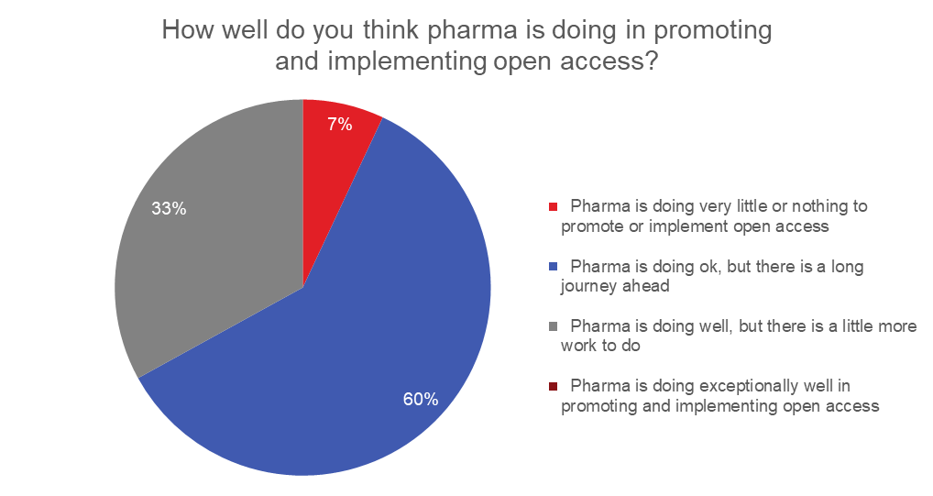
Figure 2: Poll results in response to the question “How well do you think pharma is doing in promoting and implementing open access?”, asked during the virtual roundtable meeting.

- Data from the Good Pharma Scorecard and three additional pharmaceutical companies shows that industry can achieve up to 80% open access by encouragement alone.
  - Instating a mandatory policy enables up to 100% open access.
- Although making COVID-19 research accessible has demonstrated the profound benefits of open access, it has also raised the question as to why much of the research on pandemic planning or respiratory infections remains stuck behind a paywall.
- In October 2019, Open Pharma launched its position statement on open access to ensure that “the highest quality, peer-reviewed evidence is available to anyone who needs it, anywhere in the world”.
  - The position statement has an immediate ask for authors publishing pharma-funded research to have the same rights to publish open access as authors publishing research funded by other sources.
  - The long-term goal is for pharma-funded publications to be free to read and reuse with a
CC BY license.
- The position statement already has 152 endorsements (as of June 12, 2020), eight publisher endorsements and 29 endorsements from other organizations (including two pharmaceutical companies) (Figure 3).
  - A poster presented at the virtual 16th Annual Meeting of ISMPP showed that 40% of medical publication professionals are aware of the Open Pharma position statement.
  - Almost two-thirds of meeting attendees stated that they agree with the position statement but are unable to endorse it without their company’s permission (Figure 4).
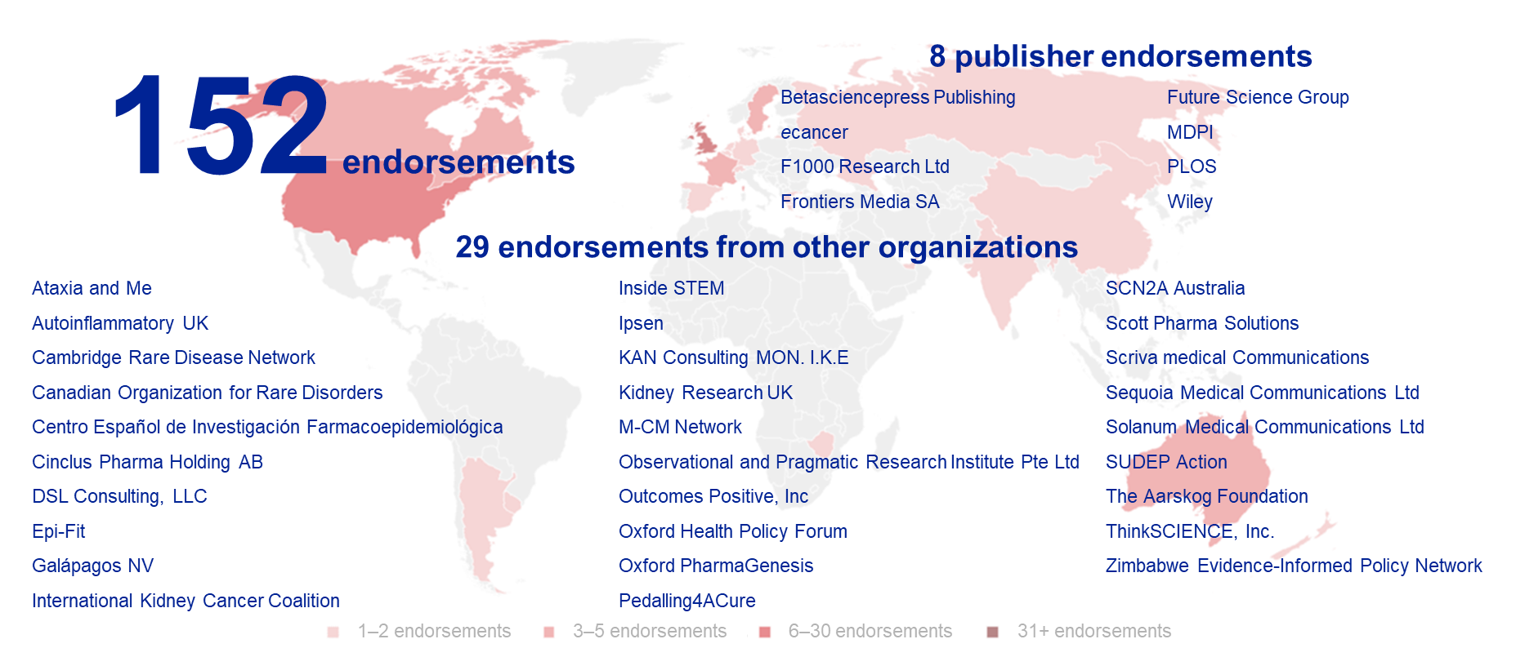
Figure 3: The reach of the Open Pharma position statement on open access (correct as of June 12, 2020)
M-CM, macrocephaly-capillary malformation; MDPI, Multidisciplinary Digital Publishing Institute; PLOS, Public Library of Science; SUDEP, sudden unexpected death in epilepsy

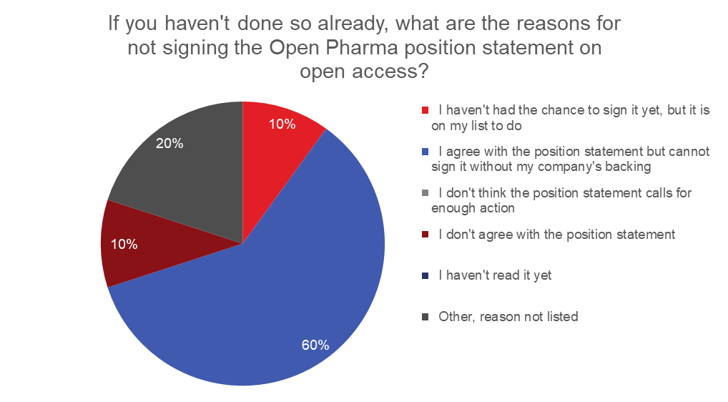
Figure 4: Poll results in response to the question “If you haven't done so already, what are the reasons for not signing the Open Pharma position statement on open access?”, asked during the virtual roundtable meeting.

Roundtable discussion
- Plan S offers the following three routes to compliance.
  - Authors can publish in an open access journal or platform, and the funder will cover APCs.
  - Authors can publish in a hybrid journal that has a transformative agreement in place (meaning that the journal has committed to transition to a fully open access model by January 2024), providing the journal is transparent about APCs.
  - Authors can publish in a hybrid journal but must make a final version of the manuscript available in an open access repository.
- To ensure alignment with cOAlition S, some Plan S signatories will no longer pay for publications in hybrid journals but will instead encourage grantees to publish in other journals.
- Attendees acknowledged that these policies create a bigger problem for researchers than publishers because they prevent authors from publishing their work in a substantial number of journals.
- While some attendees stated that hybrid journals have been a good transitional mechanism for open access, others disagreed.
- Hybrid journals were established as a way for journals to move to a fully open access model, but after many years, this transition is yet to take place.
- It was noted, however, that this transition may not be feasible until more authors publishing in hybrid journals are mandated to make their work available open access.
- This was echoed by some publishers, who highlighted that transition to full open access publishing is not sustainable and that abolishing hybrid journals altogether might have a negative impact on learned societies, who may not be ready for their journals to move to a full open access model.
- From a pharma perspective, journal models have not always been a priority, with focus placed on ensuring publications are available open access and that authors publishing industry-sponsored research have the same rights as authors publishing research funded by other sources.
- Some pharma attendees noted that they are still not able to publish their research open access in some hybrid journals, and even when they are permitted to publish open access, they are not granted a CC BY license.
- Publishers in attendance highlighted that some journals only offer CC BY-NonCommercial licenses and that these journals just happen to be a common choice for industry-funded authors.
- Attendees disagreed as to what extent pharmaceutical companies pay for journal subscriptions. Some attendees suggested that one explanation for some journals’ reluctance to offer pharma CC BY stems from pharma’s low subscription and access spend compared with other funders.
- A concern for authors and funders is that highly selective open access journals could only work by charging high APCs.
- Publishers, such as PLOS, are beginning to investigate alternate ways to fund journals that do not rely on APCs. The PLOS collective action model shifts the cost of APCs away from authors to institutes and organizations that have a strong record of publishing PLOS Medicine and PLOS Biology over the past 6 years, both as corresponding and contributing authors. This enables PLOS to distribute the cost of APCs across a broad range of organizations as an annual fee based on their engagement with the publisher. PLOS Medicine and PLOS Biology will hopefully completely transition to the collective action model by 2024.
    - PLOS editors receive no information on author funding source.
- Several publishers in attendance also highlighted that their journals do not charge
industry-funded authors higher APCs than authors with other funding sources.
- Quality and trust in science needs to be considered alongside changes in journal policies.
- Given the recent changes in scientific publishing, brought about by COVID-19, some attendees raised concerns that the rapid publication of research on open access platforms could result in the dissemination of poor-quality research.
    - It was argued that an increase in the number of articles an author publishes may not necessarily translate to greater productivity.
- Other attendees suggested that the quality of publications cannot be equated to a journals’ business model, but rather the editorial model. It would be unfair to say that open access journals are any worse at this than hybrid or subscription journals.
- Attendees suggested that static journals are an old-fashioned way of disseminating research and that science should be an ongoing conversation.
- One way to keep a scientific conversation going would be to have an iterative version of a paper available, with individual DOIs to ensure version control.
- However, evidence from some journals suggested that most researchers have little interest in carrying on the conversation once their research has been published. One such journal wanted to create tables and figures that could be updated after article publication but received a low response from authors in providing additional data.
- Attendees noted the need for a low-technology method for communicating research updates, the need for good version controls through the use of DOIs and the need for any updated articles to be subject to an additional round of peer review to ensure research quality and reproducibility.
- As highlighted by attendees, while the technology is available, authors currently lack the incentive to provide research updates.
Next steps
- Educate pharmaceutical companies on the potential benefits of read-and-publish deals and facilitate further discussions with publishers.
- Identify additional companies to approach for position statement endorsements.

Session 2: discoverability

Open access journals and patient impact
- Patients have a growing role in research, whether it is as an end user of medicines or through involvement in trial design, patient-reported outcome measurements or providing input for scientific reviews.
- The Cochrane Collaboration, for example, is training patients to be able to collaborate on systematic reviews.
- Many governments and organizations now mandate the involvement of patients in clinical research.
- However, it is estimated that patients are only able to access 25% of the research articles they need.
- Articles reporting clinical trial results are the most difficult to access, followed by
cost-effectiveness reports and rare disease research.
- This can be particularly challenging for patients with rare diseases, who may be more likely than others to seek information to help them to manage their disease. Physicians treating patients with rare diseases will not necessarily have experience in that disease area.
- Despite being heavily involved in the research process, patients have not always been considered as relevant users and have therefore not been involved in the open access debate.
- If a patient encounters a paywall, there are several routes they might take in order to gain access to research, including:
- contacting friends with university library access, other patient organizations or friends working in the pharmaceutical industry
- searching for alternative versions of the article available on open access platforms
- downloading the article from pirate sites, such as Sci-Hub
- becoming an academic researcher to gain access to sharing platforms, such as Research Gate and Mendeley
- joining a patient-centered participatory research network.
What can be done to improve patient access to research?
- APCs could be removed for patient authors wishing to publish.
- PLSs could ensure the research can be understood by the patient as well as other non-specialists, including non-specialist healthcare practitioners.
- Educational programs could be established to help improve patient health literacy.
- Metrics other than citations could be used to demonstrate research impact and encourage open access publishing.
- Patients could be included on editorial and other expert boards.
- Groups advocating open access, such as Open Pharma, could increase their engagement with the patient community.

Roundtable discussion
- Over recent years, there has been a big movement from pharmaceutical companies and regulatory bodies to involve patients in each stage of the research cycle – research done for patients should be done with patients.
- Regulatory bodies such as the Association of the British Pharmaceutical Industry (ABPI) and the European Federation of Pharmaceutical Industries and Associations (EFPIA) are working hard to facilitate and incentivize patient-centric research and development.
- Attendees highlighted that some pharmaceutical companies have been hesitant to involve patients. The development of tool kits may help pharma to better understand the best and most transparent way to involve patients in clinical research.
- Initiatives such as EFPIA’s Patient Think Tank and PARADIGM are key for encouraging communication between patients and patient organizations and pharma.
- Patients and individuals from LMIC countries may find it particularly challenging to access research, as they may face barriers in terms of infrastructure and language.
- Even when research is published open access, it is often only available in English.
- Patient organizations have large networks spanning multiple countries and regions, so they can offer support to authors in translating research. They can also act as intermediates to help facilitate communication between authors and patients looking to access their research.
    - Research4Life and Access to Research are alternative sources for individuals from LMIC countries looking to access research.
- Attendees acknowledged that more could be done to make industry-funded research available to patients and the public.
- European Union regulations require lay summaries of clinical trial reports to be made available.
- Pharmaceutical companies often have substantial communication with certain patient organizations with which they have established relationships.
- Although patients can request data directly from pharmaceutical companies, it was noted that this data often contains bias and contradicts the findings presented in the literature.
- Although patients should have the option to access basic research, some pharma attendees noted that their patient consultants have asked for the volume of research relating to their topic of interest to be condensed.
- Pharma needs to establish a way to share research with patients in an accessible format, without being perceived as ‘cherry-picking’ certain results.
- In a live poll, three-quarters of meeting participants voted that it is our (pharma’s, publishers’ and funders’) obligation to share research with patients (Figure 5).
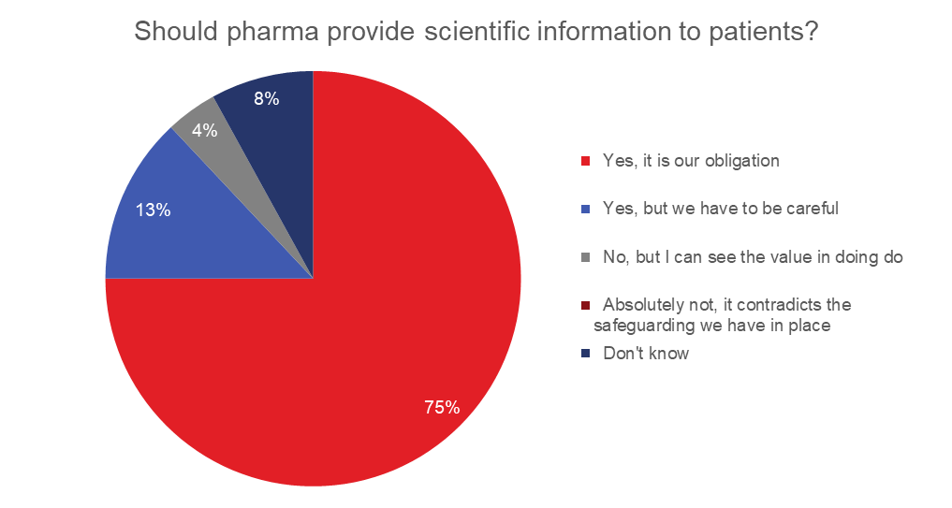
Figure 5: Poll results in response to the question “Should pharma provide scientific information to patients?”, asked during the virtual roundtable meeting.
Next steps
- Initiate a research project to establish the quantifiable proportion of clinical articles that are available to patients and the public.
  - Ascertain whether available research is qualitatively different to the research that is not available.
- Establish a patient-monitored forum to gather and explain clinical information to non-specialists.

Session 3: accountability and accessibility

Improving the use of ORCID during the manuscript publication process
- An open researcher and contributor iD (ORCID) is a persistent and unique digital identifier that distinguishes one researcher from another.
- By sharing ORCID profile information with trusted organizations (publishers, employers and funders), individual profiles can be updated, and individuals can receive recognition for the work they do.
- The use of an ORCID iD increases discoverability of an individual and their research outputs, can help to establish a network of co-authors, provided that they have linked their ORCID iD to the research output, and can link research collections together.
- Although education of pharma-affiliated employees has shown an increase in the uptake of ORCID, as demonstrated by the GSK pilot, this is not reflected in the use of ORCID in publications.
- In our research, 28% of pharma-affiliated papers and 4% of authors were listed with an ORCID iD in PubMed metadata, and 91% of authors who had authored multiple papers listed their ORCID iD inconsistently.
- Open Pharma has identified several steps in the publication process at which the visibility of ORCID could be increased (Figure 6).
- In collaboration with Open Pharma, publishers Future Science Group (FSG) and Taylor & Francis have now implemented several changes during the manuscript submission process, and data are being collected on the effects.
- Conversations have also been initiated with Adis, Anju Life Sciences, PLOS and ScholarOne.

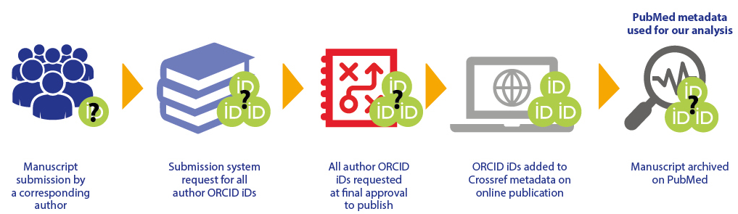

Figure 6. Publishing process stages at which an ORCID iD could be captured.

Publication plain language summaries (PPLSs)
- Some pharmaceutical companies, including GSK, Novartis and Pfizer, have started to publish PLSs alongside full-text research articles.
- Practical difficulties for this include:
- the different nomenclature used (PLS versus patient lay summary)
- determining who is the intended audience
- ensuring summaries are both accessible and discoverable.
- Novartis had internal discussions as to the added benefit of PLSs for publications when clinical results summaries are already being made available.
- Legal compliance was also a major concern; however, legal departments were happy as long as the PPLS was also independently peer reviewed and published alongside the main publication.
- An internal survey designed to identify knowledge gaps led to the production of a toolkit to ensure consistency between the pharma and oncology divisions of Novartis.
  - Most teams are now starting to look at summaries for peer-reviewed publications and conferences.
  - Internal advocacy has been key for driving this progress.
- Novartis has been working closely with Adis, FSG and Sage, in addition to patient organizations, to create stand-alone PLSs that have their own DOI and undergo peer review.
- Novartis has also created conference abstract summaries, plain language conference posters, plain language FAQs and external communications on conference abstract summaries.
- Teams are now exploring alternate channels for sharing and secondary use of plain language content.

Preprints in the time of COVID-19
- Rapid communication in medicine is key, but the need for fast dissemination of scientific research becomes even more essential during a pandemic.
- Since the outbreak of COVID-19 in January 2020, there has been growing praise for preprints (versions of a scientific manuscript posted on a public server before formal peer review).
- Authors have been able to quickly share their research, allowing others across the world to build on their findings.
- For example, a publication analyzing the full evolutionary genome sequence of the novel coronavirus was posted on medRxiv 65 days before formal publication in a peer-reviewed journal.
- In addition to the standard checks performed on many other preprint servers (such as: is the article research, or is it plagiarized?), medRxiv facilitators perform extra checks to ensure (a) that the article is not a threat to public health and (b) that there is a clear benefit to sharing now versus after peer review. MedRxiv are also looking to further strengthen their checks.
- Any papers published on medRxiv that are later deemed a health threat or to convey incorrect information can be quickly withdrawn, often within 72 hours of the concern being raised.
- The postponement or cancellation of several scientific congresses due to COVID-19 raises the question as to whether cutting edge clinical research should instead be shared as a preprint.

Roundtable discussion
- PLSs are not necessarily only for patients; for example, very few healthcare professionals have time to read full original research papers.
- Research podcasts and videos can also be used to increase research engagement and openness. Input from patients may help to ensure that an enhanced content is relevant to the end user.
    - Such content is often picked up by social media channels, which, in turn, increases the reach of the research.
- Attendees noted the need for summaries to be made accessible, not buried in the article’s supplementary files, and linked to the relevant clinical trial registry.
- Publishers have begun work with PubMed to ensure that PLSs from published research articles appear alongside the abstracts.
- Some pharma attendees shared that they have often run into compliance roadblocks when trying to share PLSs for any of their clinical studies.
    - Challenging these roadblocks by piloting PLSs in the field of rare disease might allow for expansion into other research areas.
- The perception of ‘cherry-picking’ was highlighted as a major barrier for pharma in adopting enhanced content. Some companies have been told that they must adopt an all-or-nothing approach to sharing enhanced content, which may have large financial ramifications.
    - It was suggested that pharmaceutical companies struggling to meet internal compliance could share examples from other companies.
    - Making summaries part of the manuscript submission would involve substantial input from external authors and peer review, both of which may assist with compliance. It may also result in a more cost-effective and streamlined production process.
    - However, attendees acknowledged that it may be too big a challenge for journals to peer review extensive enhanced content in additional to the full-length manuscript.
- Although publishers would like to do more to help remove these barriers for companies wishing to publish enhanced content, the lack of available templates and standards for publishing summaries and infographics makes it challenging for journals to do this at scale.
- Mid-tier journals are also unable to finance high-quality enhanced content.
- Although publication enhancements are useful, it can be challenging to ensure that they convey the correct message while also meeting the needs of the authors.
    - Authors may also require substantial education on how to communicate with a
non-specialist audience.
- Attendees questioned who should write summaries and, when medical writers are used, whether the team who wrote the manuscript should also be the team to write the summary.
- Lexicons for plain PLSs are already being developed.
- Medical writers are also being specifically trained to communicate publications to a non-specialist audience.
- It was concluded that there may be an opportunity for publishers and industry to work together to standardize this process and to determine how content can be scaled across all research articles rather than a select few.
- Many organizations are already working toward the same goals for publication enhancements, the challenge is encouraging these organizations to work together rather than in parallel.
Next steps
- Continue to engage with publishers in the implementation of ORCID into their systems.
- Curate a list of the types of enhancements offered by different journals.
- Continue to work with publishers to try and establish a standardized approach to the format and dissemination of publication enhancements.

Resources
Please find links to resources shared during the roundtable meeting below.

Transparency
Open access and author freedom from a librarian’s perspective: https://pdxscholar.library.pdx.edu/cgi/viewcontent.cgi?article=1284&context=ulib_fac
New business models established by the Wellcome Trust: https://wellcome.figshare.com/collections/Society_Publishers_Accelerating_Open_access_and_Plan_S_SPA-OPS_project/4561397
Information on the launch of the Plan S price transparency framework: https://www.informationpower.co.uk/launch-of-the-plan-s-price-transparency-framework/

Discoverability
A review of access to research in the Global South:
https://www.inasp.info/publications/access-research-global-south-reviewing-evidence
Access to Research (UK only):
http://www.accesstoresearch.org.uk/
The ABPI sourcebook for industry:
https://www.abpi.org.uk/our-ethics/patient-public-involvement/working-with-patients-and-patient-organisations-a-sourcebook-for-industry/
Information on the PARADIGM project:
https://imi-paradigm.eu/blog/

Accountability and Accessibility
A commentary on the recent COVID-19 article retractions:
https://www.nytimes.com/2020/06/14/health/virus-journals.html?referringSource=articleShare

Roundtable meeting attendees

Meeting Chair and co-Chair
Richard Smith | Patients Know Best
Tim Koder | Oxford PharmaGenesis

Members
Slavka Baronikova | Galápagos
Christine Vanderlinden | GSK
Santosh Mysore | GSK
Paul Farrow | Oxford PharmaGenesis
Catherine Skobe | Pfizer
Chris Rains | Takeda
Valérie Philippon | Takeda

Supporters
Jon Druhan | AstraZeneca
Avishek Pal | Novartis
Rikke Egelund Olsen | Roche
Linda Feighery | UCB
Gavin Sharrock | Wiley

Speakers
Ashley Farley | Bill & Melinda Gates Foundation
Will Gattrell | Ipsen
Chris Winchester | Oxford PharmaGenesis
Durhane Wong-Rieger | Canadian Organization for Rare Disorders
Sarah Sabir | Oxford PharmaGenesis
Avishek Pal | Novartis
Steph Macdonald | Oxford PharmaGenesis

Participants
Jennifer Harris | ABPI
Andrew Balas | Augusta University
Anna-Lisa Fisher | BI
Richard Sands | BMJ
Mike Taylor | Digital Science
Kirsty Reid | EFPIA
Liz Allen | F1000
Stephan Kuster | Frontiers
Laura Dormer | FSG
Jonny Patience | Informa
Rob Matheis | ISMPP
Jayme Trott | J&J
David Sampson | The NEJM Group
Shawna Sadler | ORCID
Deborah Dixon | OUP
Sara Rouhi | PLOS
Stuart Taylor | Royal Society
Pasha Javadi | Sanofi

Listening
Joanne Walker | FSG
Peter Llewellyn | NetworkPharma
Brian Falcone | Oxford PharmaGenesis
Tanya Stezhka | Oxford PharmaGenesis
Richard White | Oxford PharmaGenesis
Niamh O’Connor | PLOS

Meeting facilitation and reporting
Victoria Lee | Oxford PharmaGenesis
Debbie McNicol | Oxford PharmaGenesis
Francesca Ounsworth | Oxford PharmaGenesis
Zoe Watts | Oxford PharmaGenesis

Apologies
Shweta Rane | Alexion
Julie Newman | Gilead
Mette Holt | Novo Nordisk
Janet Davies | UCB

